Report Authors:
Fredrik Asplund, Charlotta Delin, Gunilla Ölundh Sandström

Special thanks to:
Georgios Andrikopoulos, Carina Brunn, Ann-Sofie Granberg, Carina Kjörling, Björn Möller, Susanne Nilsson

1. The M-SPAN Project
M-SPAN (Modularisering av studier på avancerad nivå) was a forward-looking pilot study on how to modularize master’s programmes to offer flexible pathways for studies, develop KTHs ability to educate and examine, and push for continuous education in skills related to higher education among KTHs teachers. To modularize a master’s program is not difficult, but to do so without alienating students or putting an unreasonable burden on teachers is complicated.
The initial plan outlines three phases (2023-09--10, 2023-11--12, and 2024-01--02) of which this report describes the first two. The first phase aimed to identify patterns at course and programme level that enables positive effects from modularization without (or with minimal) negative effects. The second phases aimed to identify barriers to implementing these patterns, specifically barriers that can be well motivated but which can (should) be removed for the benefit of a particular pattern.
Both phases were executed more or less as planned. Specifically, the first phase ended in a workshop in which several external stakeholders participated and contributed with their own perspectives; and the second phase received continuous input from several professionals with in-depth knowledge on possible (administrative) barriers.
However, it was identified quite early in the project that modularization as a means to achieve flexible pathways requires choices to be made with regard to the character of the flexible pathways that one is aspiring to. This report thus starts with describing the best practice concerning flexible pathways that we have identified (Section 2), and only then discusses their relationship to modularity (Section 3). This is followed by our analysis of these sections in relation to KTH (Section 4), and the associated administrative barriers (Section 5). The report ends with a summary of our analysis and synthesis (Section 6).

2. Best Practice Concerning Flexible PathWays
There are many current and past investigations into flexible pathways. What is presented in this section can be considered as best practice, taken more or less for granted among practitioners. We rather divide the material based on our personal perspective, i.e., based on what we expected to find, what we did not expect to find, and which associated implicit assumptions that we believe are valuable to make explicit.

2.1 At the Course Level
This describes best practice related to individual courses.

2.1.1 Expected
The following expected approaches to increase the flexibility of pathways for studies were identified:
- Through the use of digital resources. This use can be either through a part of a course (through a hybrid or blended scheme), or encompass the entire course (completely digital learning).
- Through allowing multiple start dates, i.e., by running the same course in sequence or in parallel several times during a study year.
- Through giving versions of different depth or breadth, i.e., a short, normal and extended version with increasingly large learning goals.
- Through making use of flexible exercises and assessment, i.e., making use of several different forms of learning resources, assignments, reading material, examination, etc. Although this is particularly useful for students with special needs, the approach can also be used to enable flexibility.

2.1.2 Less Expected
The following less expected approaches to increase the flexibility of pathways for studies were identified:
- Through offering courses based on the current interests of teachers or students. As an example, by having a project course that is given “on-demand” and with a number of supporting small courses to teach related “soft skills”.
- Through teaching courses outside normal working hours, i.e., during weekends or evenings.
- Through allowing students to take the exam immediately when they feel ready.
- Through assessments of (work) experience inside courses.

2.1.3 Implied
Although we could not find this discussed in relation to flexibility, master thesis project courses and capstone courses are special, self-contained courses. These are given at the end of master’s programmes to validate the skills learnt throughout the programme. However, the identified best practice suggest that they could also be offered across the programme for students that show enough skill and have a special interest in them. As an example, a master thesis project course could be given as part of a longer research study.

2.2 At the Curriculum Level
This describes best practice related to entire master’s programmes.

2.1.1 Expected
The following expected approaches to increase the flexibility of pathways for studies were identified:
- Through allowing for shorter and longer time to completion, i.e., making this a part of the planning of the programme.
- Through offering on-campus, on-work and distant versions of a programme.

2.1.2 Less Expected
The following expected approaches to increase the flexibility of pathways for studies were identified:
- Through allowing very different entry routes, i.e., putting necessary activities and resources in place to enable students to gather the necessary minimal knowledge to completely switch track when moving from a bachelor to a master’s programme.
- Through offering advanced level courses already at the bachelor level.
- Through providing specific programme courses, which guide students on which choices are available with regard to pathways for studies and what the consequences of a particular choice are.

2.1.3 Implied
Although not directly discussed, one way to enable flexible pathways for studies is to accept that there can be multiple entry and exit points from a master’s programme (see Figure 1). The former is perhaps not that surprising, but the latter would involve recognizing that a particular engineering discipline can have a breadth in which fits several, rather distinct types of engineers.
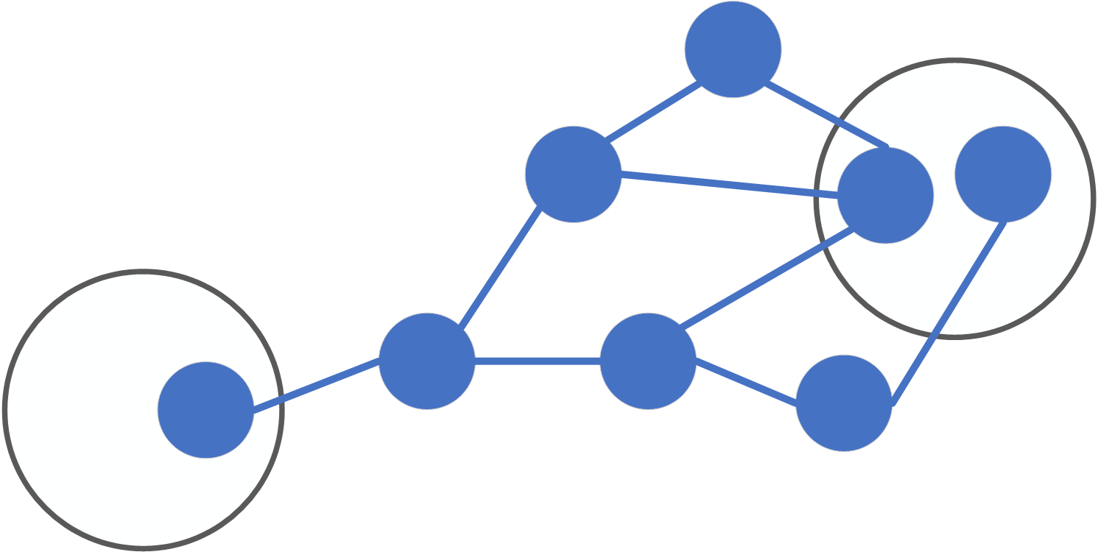
Figure 1. Different Entry and Exit Points.

3. Flexible Pathways and Modularity
During the project proposal writing MSPAN envisioned patterns for modularity, which would make it easier to use in our master’s programmes. This included several of the expected best practices for modularity identified at the course and programme level. As an example, one pattern involved giving a course based on lectures at the start of a study year, and using a hybrid approach involving pre-recorded lectures and laboratory exercises later. In hindsight these patterns used modularity through identifying a course, or part of a course, that can be reworked, given and/or examined in several different ways, and packaging the new/different versions as modules. The valuable parts of the best practice of modularity often involve how to avoid additional effort by teachers when making use of modularity in this way. Naturally, this is valuable. In fact, this is most likely one of the reasons that digital learning is so popular, as it naturally relies on modularizing content and allows at least part of it to be given with less effort.
When analyzing the less expected and implied parts of the best practice in relation to modularity, we can see another approach to modularity worth highlighting. In this approach the learning goals of a course, or part of a course, is used as the basis for modularization across several courses. In other words, this approach to modularization would rather try to identify similarities with regard to the content across several courses, and give these as modules. These similarities can be related to the contents of these courses, but also their prerequisites. Examples include common project management modules for project courses, and modules for supporting the prerequisites for a course in case the participating students come from different study pathways.
Although both these approaches to modularization are related to creating flexible and structured pathways for studies (Principle 8), they also have the potential to support other goals. The first approach also allows for student-centered learning (Principle 3), a constructive link between examination and learning (Principle 4) and the integration of life-long learning, as the same content can be given using different methods tailored to different/specific students and forms of examination. The second approach also allows for open experimental environments (Principle 5), an active campus (Principle 6) and a broad recruitment and participation by students (Principle 12), as it allows for building complete courses by linking (a) specific students’ needs and interests with (b) higher-level learning goals.
This suggests that modularity is not so much a matter of just implementing different patterns, as identifying patterns that rhyme well with the principles underlying one’s educational approach.

4. Areas of Further Analysis and Investigation
Based on the project activities (Section 1), identified best practice (Section 2), and further detailing the relationship between modularity and flexible pathways in education (Section 3), this section describes the areas that the project has deemed of interest to pursue further. Preliminary analyzes, and suggestions for how to continue the investigation, are provided.

4.1 Course Content vs Flexibility/Modularity
Many ways to achieve flexible pathways in education have been identified, but the discussions in the project have also clearly shown that most, if any, of these are not just neutral means to an end. How education is made more flexible has an effect on what the education can achieve. This means that one must first clearly establish the principles that underlies the contents of what one is teaching, before one can include more flexibility/modularity. The following subsections discuss this from perspectives identified as salient by the project participants. A future investigation in this direction could probably draw (more) inspiration from the principles for future education developed at KTH.

4.1.1 (Maintain a) Focused Recruitment
It is the opinion of the project participants that we want to provide opportunities for flexible pathways not just because it is “nice to have”, but because we want to encourage particular outcomes. In particular, we want to:
- Encourage students to study at other universities for part of their master’s programme.
- Increase the depth of students’ learning by building their education on their own interests/activities.
- Allow ambitious students to extend our courses when relevant.
- Give students as much possibility to shape their own education as practically possible.
- KTH's university-wide sustainability goal for education is that "KTH is a leading technical university in education for sustainable development where all students after graduation must be able to push for and participate in the transition to sustainable development and an equal and climate-neutral society". To solve society's need for transformation to enable sustainable futures, we need together, as students, teachers, education managers, industry and other social actors, to find forms that support this. A selection criterion could therefore be to focus on attracting students who have an attitude, awareness and willingness to work for sustainability, who want to take responsibility for enabling sustainable futures by working for all the sustainability goals, and who are driven to contribute substantially to the transformation and who choose the mechatronics program because the education feels meaningful in this regard.
Methods to increase flexibility/modularity must not go against these intentions, i.e., we want to maintain and strengthen our ability to attract students that share these interests.

4.1.2 Maintain Teacher-Student Trust
It is the opinion of the project participants that we want to build and maintain trust between teachers and students to e.g., better catch opportunities for students to design their own education. In particular, there must be ample opportunity across the curriculum for teachers and students to meet at Campus. In other words, digital and blended learning should be seen as a means towards simplifying/easing on-campus teaching through e.g.:
- Providing supporting material for students who might meet prerequisites, but still experience difficulties with course contents.
- Providing knowledge required to efficiently learn course contents, i.e., material on project management useful when learning a subject together with other students in a team.
If most of the content in a master’s programme is best given in a completely digital format, the need for the master’s programme might be called into question (at machine design).

4.1.3 Maintain Work-Life Balance
It is the opinion of the project participants that it is important to maintain the work-life balance for both students and teachers. In particular:
- As stated in the project brief, the strategies on achieving increased flexibility should not rely on a higher teacher workload. I.e., if flexibility in specific courses requires more teaching time, then the teaching time allocated to these courses should also increase.
- While teaching/learning outside normal working hours can be an acceptable solution, this should be voluntary. If teachers/students cannot, or do not want to, commit to such solutions, a course should be given within normal working hours. (Note that this does not mean that when a course is provided within normal working hours is subject to negotiation, just that it can be provided outside normal working hours for the sake of increased flexibility. This can be ensured by giving students the option to choose among times inside and outside of normal working hours, but using only the former working hours when not all students cannot commit to the latter.)
In other words, if teachers/students want to teach/study outside normal working hours it should be possible, but it should not be a requirement.

4.1.4 Increase Peer-to-Peer
Flexibility and modularity often relies on using peer-to-peer solutions. As an example, students who are first asked to learn something, and then asked to review the learning of another student, can often identify both their own misunderstandings and that of others. It is the opinion of the project participants that we should strive to use such solutions more. However, we must acknowledge that this relies on students first learning the subject, and that this means that there are circumstances when peer-to-peer solutions are not optimal. Difficult topics based on analysis and self-reflection, questions which have no right or wrong answer, times of heavy workload due to the curricula design, and subjects which are not “core”, are all examples of when peer-to-peer solutions might lead to shallow learning. Rather than just espousing peer-to-peer solutions, we should develop guidelines on how to use them in many different situations, taking both the course and curriculum level into account. For example, master theses would most likely not be ideal for peer-to-peer reviewing, as there is not much training on this kind of writing before the master thesis project. However, modules that students on the theoretical aspects of writing a master thesis could be developed in particular for enabling these reviews.

4.1.5 Increase International Cooperation
Flexibility and modularity is important during recruitment, and a part of achieving intended outcomes involving other universities. It is the opinion of the project participants that we should reach out to other universities in a structured way to support strategies for flexibility. For example, it is critical to:
- Achieve a better understanding of the profiles of international students (from particular universities/programmes) that are likely to apply to our programmes.
- Understand, and set up cooperation on, how courses can be matched against the semesters that students leave to study at other universities.

4.2 Recruiting Students vs Flexibility/Modularity
This section discusses student recruitment and participation in and through flexible study paths.

4.2.1 Recruiting students for sustainable futures
In addressing the imperative for sustainable development, education must not only prepare students for the societal transitions ahead but also embody sustainability within their programs. This involves a holistic approach encompassing curriculum revision, campus operations, and fostering a culture of sustainability.

The learning environment itself must adapt and apply a whole-institution approach to embed the philosophy of sustainable development. It involves rethinking the curriculum, campus operations, organizational culture, student participation, leadership and management, community relationships and research. (UNESCO 2018)
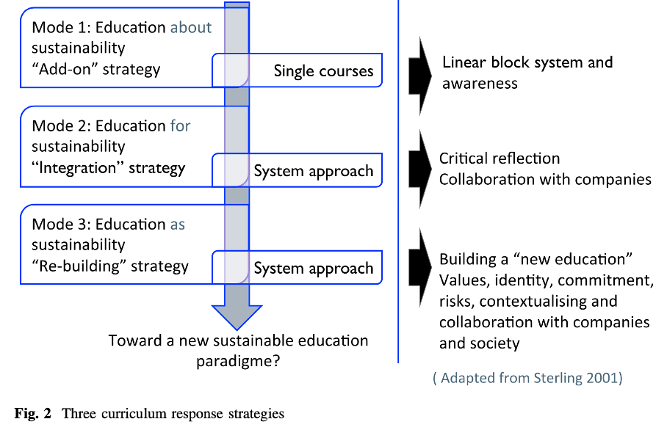Figure: Response strategies for curriculum change in engineering (Kolmos, A. et al.)

Developing skills, attitudes, systems thinking, critical thinking and interdisciplinary perspectives for sustainable futures poses great challenges for our education programs. Flexible and structured study paths (principle 8), Ability to deal with wicked problems for a sustainable social development (principle 2) and Integrated lifelong learning (principle 13) are future-oriented principles in "Future education" that can enforce each other in contributing to transforming programs for sustainable futures, enabling the development of skills and perspectives essential for navigating complex challenges.
A master program that aims to support transitions to social, economic, and environmental sustainability should integrate interdisciplinary learning, practical experiences, and have a focus on ethical considerations. By fostering an environment that encourages ethical considerations and a comprehensive understanding of societal impacts, the programs can foster students who are not only technically proficient but also socially conscious and committed to sustainability. An educational approach that supports flexibility in education is Challenge-Driven Education, a form of teaching and learning where students collaborate in projects that address complex societal challenges ('wicked problems') linked to sustainable development and transformation, in collaboration with companies, public sector, and civil society. Challenge driven education could potentially be beneficial also for lifelong learners,
To reach diversity and interdisciplinarity the students admitted to the master programs could potentially have different disciplinary backgrounds, as long as they fulfill, or are given the opportunity to supplement, the necessary basic competences. In order to attract students with different backgrounds, experiences, genders and identities, the content, design and implementation of the education needs to be such that it as a whole feels relevant and inclusive, and on equal terms, for a wide group, including international students.
The students we thus want to attract preferably:
- Come from diverse backgrounds, including various academic backgrounds, to foster interdisciplinary collaboration and innovative thinking.
- Have a passion for sustainability, who have a strong commitment to creating technologies that are environmentally friendly, socially responsible, and economically viable.
- Show ethical awareness, who understand the ethical implications of their work and are committed to upholding values like fairness, inclusivity, and gender equality.
- Are problem solvers, who thrive on solving complex problems, have a creative mindset, and can apply theoretical knowledge to practical solutions.
- Are collaborators that value teamwork, communication, and are eager to collaborate with diverse groups to address multifaceted challenges.
It is unlikely that instrumental attempts to attract a student population that reflects society at large would make any difference. The difficult question that needs to be asked is how we can change the values and culture and work for an education where different knowledge and experiences are valued and taken advantage of, where different people feel that they are at KTH on equal terms and without discrimination or harassment, see meaning in to study at KTH, and can be involved in influencing education and the future.
Flexible study paths may also mean an increased personal responsibility for the students to choose content (eg. courses and modules), design (eg. pace) and implementation (eg. form) of the education in a way so that they meet the learning objectives of the program. This must be clear for the students applying to the program and the framework for the education must be clearly supportive.
So who is excluded, that we may need?

4.2.2 How to Avoid Hurting Recruitment of Students
Research shows that engineering education values and reproduces white, masculine, Western knowledge (see e.g. Ottemo et al 2020). If we assume that the standard student is a European young neurotypical man with full physical functionality who celebrates Christian holidays and comes from a relatively high socio-economic capital, then who is missing that the education needs to attract and provide space on equal terms? On the one hand, it is important to identify who is missing, but on the other hand, it is problematic to categorize groups as it risks reinforcing stereotypes. Intersectional perspectives are required on how different power structures express themselves in education. What is there in the education program’s content, design and implementation that is possibly missing, or needs to be changed, so that all potential (norm-breaking) students can participate on equal conditions? What are the processes that enable or prevent students to feel welcome, comfortable and included in the education? For example, distance learning during the pandemic made some students "get closer" to their education, and made it easier to participate in the education, while others experienced increased obstacles to participation.

And what other ways than grades could be possible ways to enter the program?

Acknowledging the historical biases in engineering education, it's crucial to challenge conventional norms and embrace intersectional perspectives. By recognizing and addressing systemic barriers, we can create an environment that welcomes students from diverse backgrounds. Alternative pathways to entry, beyond traditional metrics like grades, can broaden access and ensure representation from underrepresented groups.

4.2.3 Advantages and Challenges of Flexibility Approaches
Implementing flexible study paths, including interviews as part of the recruitment process, online learning, multiple start dates, varied course lengths, and diverse assessment methods, presents both advantages and challenges across different student populations.
Although these approaches may offer increased accessibility and adaptability, diversity and inclusion, it’s important to consider diverse student needs and circumstances when designing flexible learning approaches. E.g;

Full-time Students
Advantages:
- Multiple start dates allows for more flexibility in scheduling courses.
- Short, normal, and extended course versions cater to different learning paces and preferences.
- Use of digital resources facilitates access to learning materials and flexibility in study locations.
Challenges:
- Courses taught outside normal working hours might conflict with other commitments or personal time.
- Longer time to complete may extend the overall duration of the program.
Working Professionals, Older Students, Part-time Students
Advantages:
- Courses taught outside normal working hours allows for studying while balancing work commitments.
- "Challenge for credit" provides flexibility in exam scheduling.
- Prior learning/competency assessment recognizes existing skills and experiences, reducing redundancy.
Challenges:
- Multiple start dates might require careful planning to align with work schedules.
- Balancing work and study commitments may prolong the duration of the program, thus longer time to complete.
International Students, Students not Living in Stockholm
Advantages:
- Offering on-campus, on-work, and distant versions provides flexibility in study modes, accommodating different geographical locations.
- Cooperation to transfer students between programs/institutions facilitates mobility and access to education across borders.
Challenges:
- Time zone differences may pose challenges for participation.

It requires careful planning and support to ensure equitable opportunities for all students. Emphasizing inclusive curriculum design, support services, and community-building initiatives can enhance the effectiveness of flexible study paths in promoting student success and fostering a sense of belonging.

4.2.4 Recommendations for Enhancing Recruitment and Flexibility
To further enhance recruitment strategies and flexibility in education, we recommend exploring additional approaches, such as conducting interviews as part of the recruitment process. Interviews can serve as a valuable tool to assess candidates' alignment with program values, problem-solving abilities, and commitment to sustainability. Emphasizing the interdisciplinary nature of the program and the benefits of flexible study paths during interviews can attract a diverse range of applicants. Additionally, ensuring inclusive and equitable interview processes is essential to promote diversity and inclusivity in student recruitment.

4.3 Challenge-driven Pop-up Courses
During the work on this report we came across the concept of “challenge-driven pop-up courses” used by Chalmers. The following section describes and makes recommendations regarding this concept.

4.3.1 Description
The challenge-driven pop-up courses are named “Tracks courses”, and are part of Chalmers' regular education offering. However, they do not belong to any specific program or individual department. The courses are cross-disciplinary and optional. They are open to all Chalmers students in grades 2–5 and to Chalmers alumni. They are organized outside the regular system and can be started quickly, within a few months. The size of the courses is 7.5 credits or 15 credits.
The following critical aspects of the concept have been identified:
- The courses have their own admission system and administrative system.
- The courses have a shorter administration time and the courses can in principle go from idea to students on the courses in three months, but in practice Chalmers usually collects ideas once every six months.
- As support for those giving the courses, there are digital modules ready for teachers to choose from in order to meet requirements for skills such as JML, sustainability, teamwork, ethics and communication. The teachers thereby have a support structure with these digital modules and can focus on the challenge solution and the technology.
- The courses are organized in tight collaboration with a MakerSpace.
- Collaboration between the courses and industry is encouraged.

4.3.2 Recommendations
We recommend that:
- How KTH can create support for project courses through digital “skills'” modules is reviewed.
- Whether and how KTH can make use of flexible "pop-up" courses is reviewed. We believe this could be useful by providing a faster route to experimental project courses, new technology in e.g. doctoral projects, increased collaboration between students in different programs, and projects that try to meet societal challenges with students from different programs.

5 Administrative Barriers
In relation to the analysis in the previous sections there are administrative barriers that need to be understood. The following section describes the most important ones, and in particular what they are based in. The project scope did not allow for looking further into requirements on the recruitment of (master) students, working/study hours, informing/involving students, and industri-hosted trainee courses, although they were discussed as potentially involving administrative barriers in need of investigation.

5.1 Requirements on a Master’s Degree
The Higher Education Ordinance requires that:
- A Master’s Degree includes 120 ECTS, of which 60 ECTS must be within a particular subject area.
- A Master’s Degree includes an independent master’s thesis project of at least 30 ECTS.
- Master’s Programmes ensures that students meet specified requirements with regard to their (a) knowledge and understanding, (b) skills and abilities, and (c) evaluation ability and approach.
These requirements must be fulfilled by our master’s programmes.
KTH specifies this further by requiring that:
- 90 ECTS (out of the 120) must be at the advanced (master’s) level.
- The education plan for each master’s programme can specify the generic requirements in further detail.
These requirements must be fulfilled as long as KTH does not change them. The requirements in the education plan can be changed by applying to the ITM School Faculty Board.

5.1.1 Recommendations
We recommend that:
- A joint requirement for Master's programs of a certain number of credits that should be optional for the students is investigated. Today, the requirement varies between KTH's master's programs and many have a low degree of freedom of choice.

5.2 Requirements on Scheduling
KTHs President each year decides on the exact placement and planning of one or more upcoming school years.The decision is prepared in the board of education. The decision must be made no later than the 30th of June two years before the school year starts.
There are some directives that decide scheduling at KTH, there are specific dates for when the schedule shall be published and those dates then decide when teachers need to finalize their schedules. Despite the guidelines enumerated below, many aspects of scheduling can regardless be adapted to the wishes of teachers. However, this might require an application by the relevant KTH school to KTHs president.

5.2.1 Schedling
More information is available in the official decisions by KTHs president.
- Teaching and examinations are held primarily on weekdays at 8:00 – 17:00.
- The schedule shall be published no later than May 1 before the fall semester and no later than November 1 before the spring semester.
- The schedule of classes should not be changed after it has been published.
- Schedule for the exam shall not be changed after it has been published.

5.2.2 Scheduling “Modules”
At master's level, a “module” schedule is applied. This means that the schedulers assign each course to a set of “modules”, i.e. fixed time slots per week. The slots have been created by assigning each 2-3 hour slot during a working day its own name. There are thus 25 “modules” and a one-to-many mapping between “modules” and courses. This means that the “module” schedule provides little support for scheduling of courses so that students know what courses they can take based on the “modules” they are in. In fact, the “modules” for each course are not communicated to students. The “module” schedule is not applied for exams and re-exams.
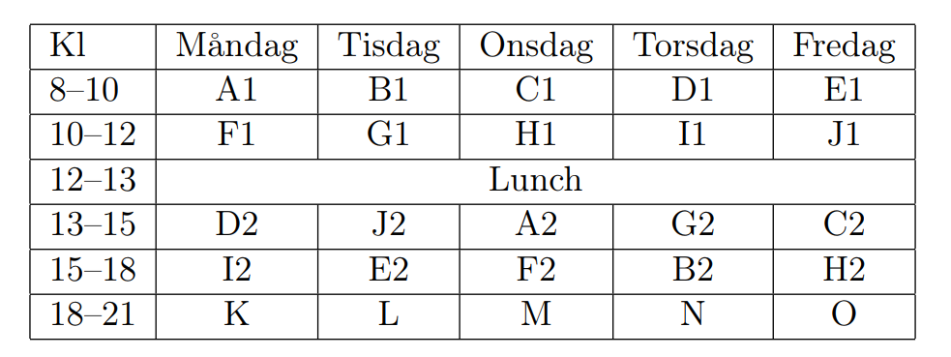

5.2.3 Recommendations
We recommend that:
- A smaller, distinct set of “modules” (i.e., time slots) is created, so that courses can be assigned to these and this mapping communicated to students to ease their course selection.
- Exams are also connected to “modules”, to facilitate students’ combination of courses.

KTH's university-wide sustainability goals 2021-2025 and climate goals 2021-2045. https://intra.kth.se/polopoly_fs/1.1046728.1612424906!/KTHs-universitetsovergripande-hallbarhetsmal-2021-2025-och-klimatmal-2021-2045.pdf
Among the thirteen principles for a future higher education developed by KTH (https://intra.kth.se/styrning/framtidens-utbildning/beslut/principer-1.1197995)
See e.g., “Riktlinje om läsårets förläggning och planering, V-2021-0377 1.2”.
See e.g., “Införande av modulschema på KTH:s masterprogram, V-2014-0453”
https://www.chalmers.se/utbildning/studera-hos-oss/valj-chalmers/tracks-unikt-utbildningskoncept/ #bakgrund-till-tracks
For example, Chalmers has four “blocks” (A, B, C and D) which have 10 hours of slot time per week.

