Should I complete the export control checklist?

Please contact exportcontrol@kth.se directly if you prefer that instead of using this checklist. The figure below is meant to help researchers assess whether support from export control officers is necessary.

Instructions
- What will you transfer?
- Where is it transferred?
- If red/striped, then complete the check list.

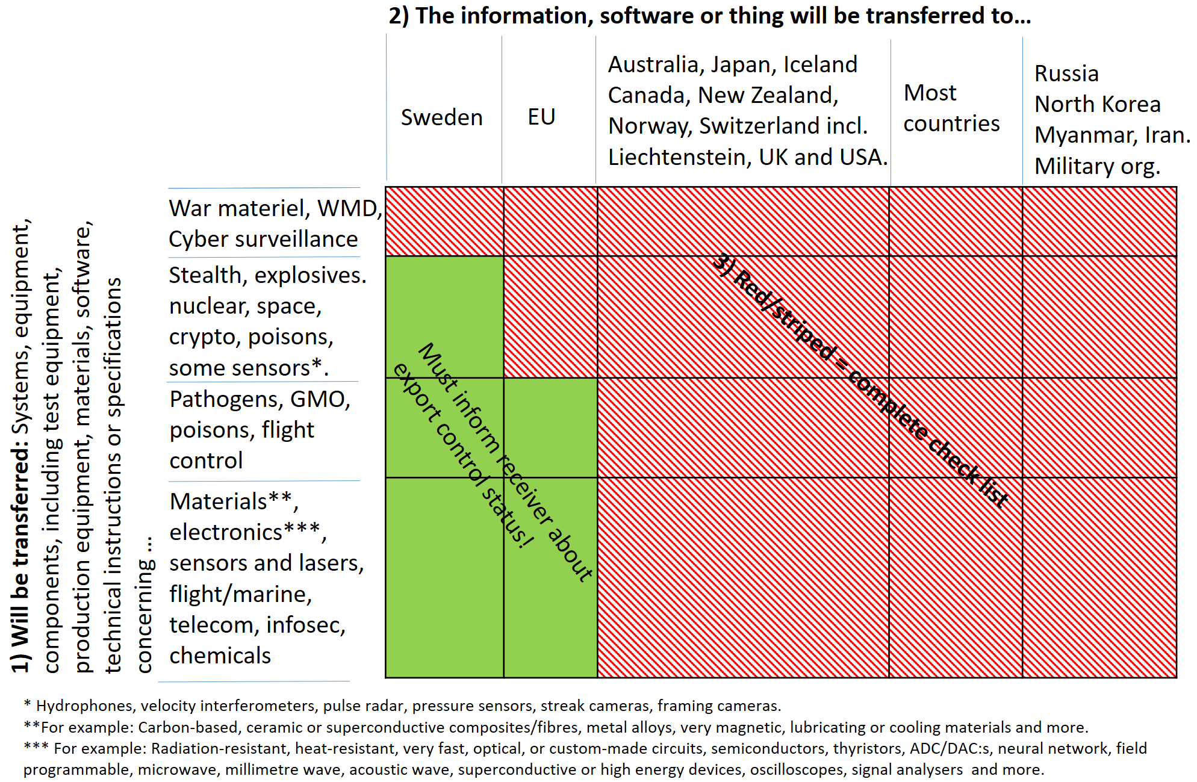

Checklist for export control
According to KTHs guidelines on export control, each person responsible for a project or other part of KTH operations is responsible for classifying information, technical data, software, and hardware and performing due diligence within their project according to current export control legislations. For practical reasons, this should be done before a project starts, and any assessment on export control may need to be updated at any time if the project change. This checklist is intended to facilitate such assessments.
In order to ensure that KTH follows the export control regulations, it is important to assess whether an export license is needed. For a brief summary of what dual use, export, and technical assistance are, please see point 1 on page 5. If the review of the project/activity indicates that an export license or consultation with the Supervising Authority is necessary, Research Support Office will assist you with the process. You will find a short guide and useful links at the end of this checklist.
If you need help completing the checklist, please email exportcontrol@kth.se.

Project title/Acronym
Principal Investigator | Date

Section 1.
If the answer to any of the questions in this section is" yes" please seek assistance from exportcontrol@kth.se.

Will you in your project handle, generate, or exchange information, technical data, software, or hardware that:

1.1. Is intended for military purposes? | Yes: ☐  No: ☐
1.2. Can be used in the development, production, handling, use, maintenance, storing, detection, identification, or proliferation of chemical, biological, or nuclear weapons or missiles? | Yes: ☐  No: ☐
1.3. Can be used for cyber-surveillance? | Yes: ☐  No: ☐

Section 2.
If the answer to any of the questions in this section is" yes" please seek assistance from exportcontrol@kth.se. Also, consistently report the reply to 2.1.2 to the same address (also state the project's name if available).
Will you in your project handle, generate, or exchange information, technical data, software, or hardware that:

2.1. Is listed in the Dual Use Annex I Regulation (EU) 2023/2616?  (find information at point 2, page 5 on how to navigate the regulations) | Yes: ☐  No: ☐
2.1.1. If "yes", what category/categories and control numbers in the regulations are applicable to your work?  (if multiple items, list all of them) | Click here to enter text.  Click here to enter text.  Click here to enter text.
2.1.2. If "no", what category/categories and control numbers in the regulation have you checked?  (please specify) | Click here to enter text.  Click here to enter text.  Click here to enter text.
2.1.3. If "yes", is any of the items or information specified in Annex II of the Dual Use (EU) 2023/1? | Yes: ☐  No: ☐
2.2. Contains anything of US origin or that is listed in the Commerce Control List Index?  (find information at point 3, page 7, regarding US origin) | Yes: ☐  No: ☐
2.2.1. If "yes", please list the ECCNs of all potential dual-use items with US origin. | Click here to enter text.  Click here to enter text.  Click here to enter text.
Section 3.
If the answer to any of the questions in this section is" yes" please seek assistance from exportcontrol@kth.se.
Will you, in your project, exchange information, technical data, software, or hardware to any country, party, or person that:

3.3. Is listed in the EU sanctions map?  https://www.sanctionsmap.eu/ | Yes: ☐  No: ☐
3.3.1. If "yes" which party or country is involved? | Click here to enter text.  Click here to enter text.  Click here to enter text.
Section 4.
Only applicable if you have answered "yes" to any of the questions in sections 1-3.
If the answer to any of the questions in this section is" yes" please seek assistance from exportcontrol@kth.se.
Will you, in your project, exchange information, technical data, software, or hardware to:

4.1. Any country outside of the EU? | Yes: ☐  No: ☐

4.1.1. If "yes", which countries are involved? | Click here to enter text.  Click here to enter text.  Click here to enter text.
4.2. Any party or person that has military connections? | Yes: ☐  No: ☐
4.2.1. If "yes", specify parties/persons: | Click here to enter text.  Click here to enter text.  Click here to enter text.
Section 5.
Only applicable if you have answered "yes" to any of the questions in sections 1-3.
If the answer to any of the questions in this section is" yes" please seek assistance from exportcontrol@kth.se.

Do you think that an exception from export control may be applicable to the project?

5.1. If so, which exception are you referring to in the EU regulation?  (please find information at point 4, page 7 regarding de-control) | The one on "basic scientific research": ☐  The one on "in the public domain": ☐  The one on the minimum necessary information for patent applications: ☐  Other, namely: Click here to enter text.
5.2 If "yes" on 2.2, which exception are you referring to in the US regulation?  (please find information at point 5, page 8 regarding de-control) | The one on "fundamental research": ☐  The one on "published": ☐  The one on the minimum necessary information for patent applications: ☐  Other, namely: Click here to enter text.

Point 1)

Article 2 Regulation (EU) 2021/821 for definitions on 'dual use items', 'export', and 'technical assistance:
- 'dual-use items' means items, including software and technology, which can be used for both civil and military purposes, and includes items that can be used for the design, development, production, or use of nuclear, chemical, or biological weapons or their means of delivery, including all items which can be used for both non-explosive uses and assisting in any way in the manufacture of nuclear weapons or other nuclear explosive devices;
- 'Export' includes (amongst other things):
- Hardware that is brought out of the European customs area.
- Transmission of software or technology by electronic media, including by fax, telephone, electronic mail, or any other electronic means to a destination outside the customs territory of the Union; it includes making available in an electronic form such software and technology to natural or legal persons or partnerships outside the customs territory of the Union; it also includes the oral transmission of technology when the technology is described over a voice transmission medium;
- 'technical assistance' means any technical support related to repairs, development, manufacture, assembly, testing, maintenance, or any other technical service and may take forms such as instruction, advice, training, the transmission of working knowledge or skills, or consulting services, including by electronic means as well as by telephone or any other verbal forms of assistance;
Point 2)
A short guide to searching the Dual Use regulation
- Click one of the links to the dual-use regulation: Annex I Regulation (EU) 2023/2616
- Search the document for relevant keywords, generally describing the item (or software or technology) at hand (for example, 'cryptography', 'radar', 'mass spectrometer', 'laser').
- Check the search hits. The most important ones are hits in a paragraph with a five-digit code to the left.
- Assess whether the specifications of paragraphs with the five-digit code fit the item, software, or technology at hand.
- Fill out the checklist above accordingly and send it to exportcontrol@kth.se

Structure of the Dual Use regulation, Annex I containing items with dual use
The text below is a translation of the information on the ISP website https://isp.se/pda/klassificering-av-produkt-och-teknik/innehall-i-bilaga-i/
The Annex 1 to the Dual-use regulation contains the list of dual-use items and is structured like this:
Introduction
Notes
Acronyms and abbreviations
Definitions
Categories and sub-categories
The products are divided into the following nine categories (0-9):
0 – Nuclear materials, facilities, and equipment
1 – Special materials and related equipment
2 – Materials processing
3 – Electronics
4 – Computers
5 – Telekommunikation och ”informationssäkerhet”
6 – Sensors and Lasers
7 – Navigation and avionics
8 – Marine
9 – Aerospace and propulsion
Each category is divided into five sub-categories:
A – Systems, Equipment, and Components;
B – Test, Inspection, and production equipment;
C – Materials;
D – Software;
E – Technology
Control numbers
Each controlled product has a control number with five positions. The first and second denote which category and sub-category the product belongs to. The third position shows the export control regime that regulates the product – 0 is the Wassenaar arrangement (WA), 1 is the Missile technology regime (MTCR), 2 is the Nuclear Suppliers Group (NSG), and 3 is the Australia Group (AG). The fourth and fifth position is the serial number.
Example: 3A001
Explanation: 3 = Electronics, A = Systems, Equipment and Components, 0 = WA, 01 = Serial number.
Definitions and notes
When going through the dual-use list, it is important to read the definitions and notes. Definitions between 'single quotation marks' can be found in the technical notes below the control number of a product. Definitions between "double quotation marks" can be found in the introduction to the dual use list (Annex I).

Point 3)

US origin
Items (including things, software, and information) of US origin should be treated as being subject to the US legislation Export Administration Regulations (EAR) if it is a condition of agreements, is beneficial for relations with US partners, and does not contradict Swedish law. Items that may not be perceived as of US origin (never even passed through US territory) may still need to be handled, even when in Sweden or otherwise outside the USA, concerning the EAR. Items of US origin include items that:
- have been manufactured or otherwise originated in the USA, or
- have parts or software originated in the USA, or
- have been directly manufactured (anywhere) based on US technology or software, or
- have been manufactured (anywhere) in a plant that is based on US technology or software (EAR § 734.3).

Point 4)

If something is listed in the EU Dual-Use regulation with section E (Technology) of category 1-9 or section E (Technology) of category 0, de-control may apply. Always consult exportcontrol@kth.se if you think de-control applies. To read more regarding the exceptions, search the regulations Dual Use regulation, Annex I using GTN and NTN as your keywords.

Basic scientific research
Definitions of "Basic scientific research" (GTN NTN) means experimental or theoretical work undertaken principally to acquire new knowledge of the fundamental principles of phenomena or observable facts, not primarily directed towards a specific practical aim or objective.

It has been interpreted by the Inspectorate of Strategic Products (ISP) as applying to research that takes place at max Technology Readiness Level (TRL) 2. To transfer or export research results that reach maximum TRL2 does not need an export permit (given that general clauses do not take effect, see section 1 in the checklist). The basic research exception only applies to technology and not software or things.
For an explanation of Technology Readiness Levels, please see below (COMMISSION RECOMMENDATION (EU) 2021/1700, appendix 8.)
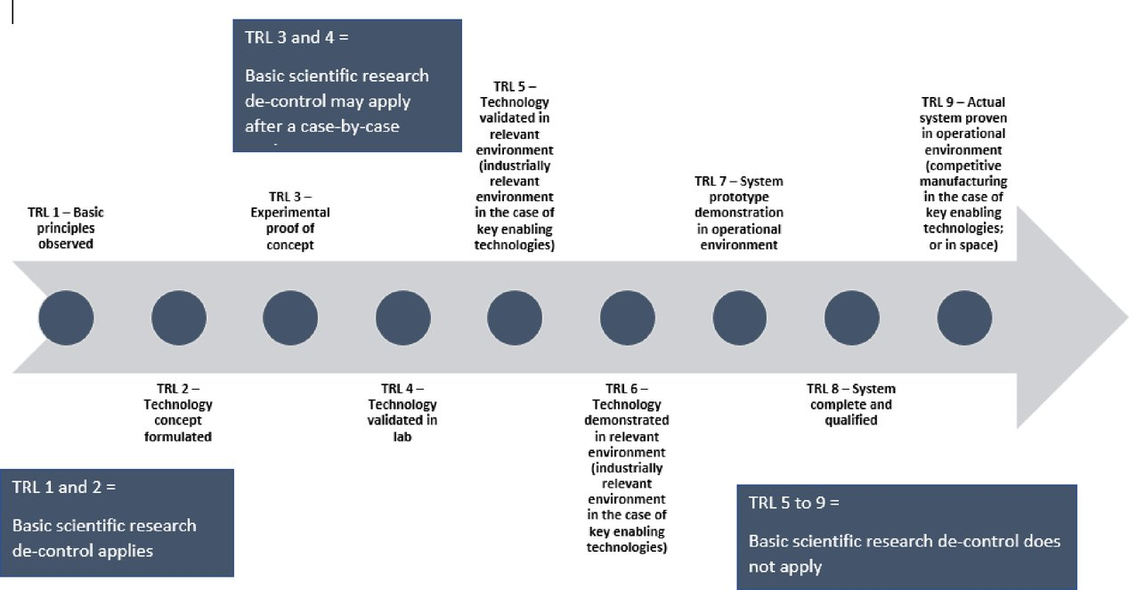

In the public domain
Technology that is already in the public domain is also exempt from the legislation. In the public domain, for example, scientific articles, unlocked websites, or books. Public access is not considered to be something that needs to be purchased by a supplier who checks the availability of certain groups or persons, commercial/academic confidential information, or information classified by authority.
Note that making technology publicly available is still subject to a permit (unless done through a patent application.

The minimum necessary information for patent applications.
Technology that is necessary to disclose in a patent application may be disclosed there, even if it involves the dissemination of the technology. However, this does not apply to technology that has any direct connection with PDA that belong in category 0.

Point 5)
According to EAR §734.3(b)(3) the following are not subject to the EAR:
Information and "software" that:
- Are published, as described in § 734.7;
- Arise during, or result from, fundamental research, as described in § 734.8;
- Are released by instruction in a catalog course or associated teaching laboratory of an academic institution;
- Appear in patents or open (published) patent applications available from or at any patent office, unless covered by an invention secrecy order, or are otherwise patent information as described in § 734.10;
- Are non-proprietary system descriptions; or
- Are telemetry data as defined in Note 2 to Category 9, Product Group E (see Supplement No. 1 to part 774 of the EAR).
NOTE TO PARAGRAPHS (b)(2) AND (b)(3): A printed book or other printed material setting forth encryption source code is not itself subject to the EAR (see § 734.3(b)(2)). However, notwithstanding § 734.3(b)(2), encryption source code in electronic form or media (e.g., computer diskette or CD ROM) remains subject to the EAR (see § 734.17)). Publicly available encryption object code "software" classified under ECCN 5D002 is not subject to the EAR when the corresponding source code meets the criteria specified in § 742.15(b) of the EAR.
NOTE TO PARAGRAPH (b)(3): Except as set forth in part 760 of this title, information that is not within the scope of the definition of "technology" (see § 772.1 of the EAR) is not subject to the EAR

Please find more information here:
Uppgifter och beslutanderätt inom exportkontroll – KTH’s guidelines regarding export control
KTH export control homepage – including the KTH export control programme
Commission recommendation (EU) 2021/1700 – recommendation on internal compliance programs (ICP)
Guidance note: Research involving dual-use items – a short guide from the EU Commission regarding research and dual-use
Guidance note: Potential misuse of research – a short guide from the EU Commission regarding misuse of research.
Export Control in Science and Research and Export Control and Academia Manual – two guides produced by the German BAFA regarding export control, science, and research.

