Stockholm, 16 March 2023

Welcome Letter for students admitted to

KTH Master’s Programme: X

Dear Name
On behalf of KTH Royal Institute of Technology, Stockholm, we are pleased to welcome you to the Master’s programme X starting in August 2023.

Duration of the Programme
Two years of full-time studies and a total of 120 ECTS credits, which entail three terms of course work and one term devoted to a degree project. Upon completion of the programme you will be awarded the Swedish degree: Teknologie masterexamen. Translated into English as: Degree of Master of Science (120 ECTS credits).

Mandatory School Introduction
dag, månad, 2023 – School, location, contact person, address

Please bring a valid photo ID/passport. This meeting will provide you with important information about your school and other study-related information. You will also be introduced to the premises and to several school representatives and your student union chapter. It is important to know that attending your school introduction is mandatory. If you are prevented to attend due to extenuating circumstances, you will have to submit an exemption form. For more information, please visit: New at KTH.

Conditionally Accepted
If you have been conditionally admitted to studies at KTH and have not yet submitted your bachelor’s degree, you have to present your original degree certificate/diploma and your official transcript of records in its original language and English translation to the KTH Admissions Office. To do so, you should upload your documents (in colour) to your University Admissions account before October 31, 2023. If you are unable to upload your documents before October 31, you need to contact the KTH Admissions office as soon as you have received your documents. If you are admitted to a joint programme, other instructions may apply.

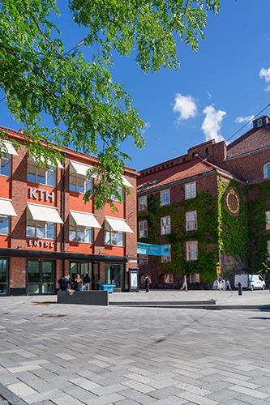
Arrival Days
Arrival days are organized to give you a smooth arrival and to ensure that you get the information needed for a good start at KTH. We recommend that you schedule your arrival to one of the appointed Arrival days on 19 or 20 August, in order to benefit from the additional services offered and to be ready to attend the mandatory school introduction (see p.1). For students that have housing contracts with KTH Accommodation starting
1 August, there will also be an additional Key pick-up day.
Arrival day services at Arlanda Airport
Student guides will welcome you at the airport and there will be a free shuttle bus service from Arlanda Airport to KTH Campus.
Arrival day services at KTH Campus
The Arrival day site, located at KTH Campus, will be open
10.00-22.00. You will be able to:
- Store your luggage at the free luggage service.
- Get your KTH access card.
- Sign your housing contract and pick up your keys, if you have accommodation provided
by KTH.
- Get your personal KTH-account. This allows you to connect to the Wi-Fi network and to get started with the other IT-services. Please bring your passport or valid photo ID.
- Meet with the Arrival day crew.
- Meet and mingle with the student union, THS. Take the opportunity to talk to fellow students and make new friends.
When preparing for your arrival at KTH, make sure to read the newsletters sent out by email and to visit www.kth.se/newatkth regularly to get updated information regarding Arrival days and the introduction services.

We look forward to seeing you in August.

Kind regards,
KTH Royal Institute of Technology
……………………………………..
Coordinator/ Contact details
Master’s programme
KTH School

