DPIA Template
This is a template for data processing impact assessment (DPIA). Further information concerning a DPIA, please visit < https://intra.kth.se/en/anstallning/anstallningsvillkor/att-vara-statligt-an/behandling-av-person >

Document version controll

Version | Date | Date of publication
KTH_DPIA_01.00_eng | September 26, 2022 | September 26, 2022

Submittning Controller Details
Name of participant | Contact details (email and telephone) | Position
Measures approved (approved by and date)
Klicka eller tryck här för att ange datum.

Step 1 – Identify the Need for a DPIA
Do KTH the need a DPIA (Yes/No) | Yes | No
 | ☐ | ☐
Summarize why KTH don´t need a DPIA

Step 2 –Desciption of the Nature of Processing, the Purpose and Proportionality of Thereof
Describe the nature and the scope of the processing [1]
Can there be a dependency between the KTH/researcher and the data subject?

Describe compliance and proportionality measures

Information to the data subjects

Step 3 – Technical Description
Data management

Step 4 – Risk management
KTH´s general risk assessment (https://intra.kth.se/administration/informationssakerhet/ledningssystem-for-informationssakerhet-lis-1.521737 ) is the stepping stone for the risk management.
First, all the circumstances and risks are taken into account in order to achieve the desired result. Describe the risks briefly, including their impact and/or consequences for individuals. Please include risks for the university as such where it may be applicable. Examples of risk areas are IT or physical security, Communication and Reputation.
Second, a risk assessment is made of the probability that the respective risk will occur and what consequence this would have.

Probability (likelihood of harm)
- Unlikely: Virtually non-existent risk
- Small probability: It is unlikely to occur under normal circumstances, at least not frequently.
- High probability: It may well happen, but probably not very often.
- Very high probability: It will happen and often.

Consequence (severity of harm)
- Negligible: Minimal and remote impact
- Mild: The consequence is not negligible but can be managed in the day-to-day work.
- Serious: Serious disruptions to operations that may affect our reputation.
- Very serious: Extensive consequences for the business.

Description of the severity and the likelihood of harm
If needed, extra risk assessment can be added to the DPIA.
Risk assessment # 1
Description of the risk

Description of the consequence
Consequence | ☐ | Very serious– 4 | ☐ | Mild - 2
 | ☐ | Serious – 3 | ☐ | Negligible - 1
Probability | ☐ | Very high probability - 4 | ☐ | Small probability - 2
 | ☐ | High probability - 3 | ☐ | Unlikely - 1

Risk assessment # 2
Description of the risk

Description of the consequence
Consequence | ☐ | Very serious– 4 | ☐ | Mild - 2
 | ☐ | Serious – 3 | ☐ | Negligible - 1
Probability | ☐ | Very high probability - 4 | ☐ | Small probability - 2
 | ☐ | High probability - 3 | ☐ | Unlikely - 1

Risk assessment # 3
Description of the risk

Description of the consequence
Consequence | ☐ | Very serious– 4 | ☐ | Mild - 2
 | ☐ | Serious – 3 | ☐ | Negligible - 1
Probability | ☐ | Very high probability - 4 | ☐ | Small probability - 2
 | ☐ | High probability - 3 | ☐ | Unlikely - 1

Risk assessment # 4
Description of the risk

Description of the consequence
Consequence | ☐ | Very serious– 4 | ☐ | Mild - 2
 | ☐ | Serious – 3 | ☐ | Negligible - 1
Probability | ☐ | Very high probability - 4 | ☐ | Small probability - 2
 | ☐ | High probability - 3 | ☐ | Unlikely - 1

Risk assessment # 5
Description of the risk

Description of the consequence
Consequence | ☐ | Very serious– 4 | ☐ | Mild - 2
 | ☐ | Serious – 3 | ☐ | Negligible - 1
Probability | ☐ | Very high probability - 4 | ☐ | Small probability - 2
 | ☐ | High probability - 3 | ☐ | Unlikely - 1

Step 5 – Actions to be taken in order to minimize the risks
A balance of probability and consistency for each risk is made, resulting in a
risk assessment in the categories low, medium, high and very high.

.
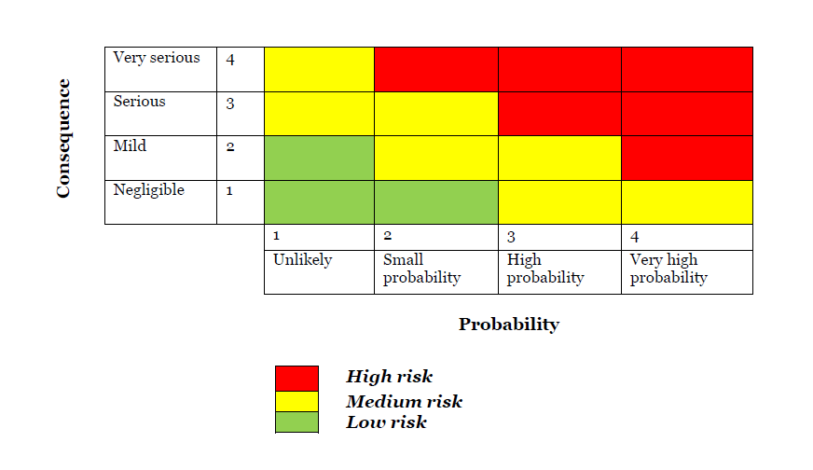
The next part, involves making decisions about how the risk should be managed, whether it should involve measures and, if so, which ones.
  - Accepting risk means that no action is taken. This may be because the impact on the project/what is assessed is minimal or that the costs of action are too high. It may also be that the risk is completely affected by external events.
  - Limiting risk means reducing the likelihood and/or consequences of an event occurring.
  - Eliminating risk means that the activities associated with the risk are avoided or managed in such a way that the risk disappears

Please note that if there are still high risks with the processing even though measures have been put in place, a consultation with the Swedish Authority for Privacy Protection (IMY) must be carried out.

Risk | Risk | Measures to limit or eliminate the risk

Risk assessment # 1

Risk assessment # 2

Risk assessment # 3

Risk assessment # 4

Risk assessment # 5

Step 6 – Summary of Impact Assessment Carried Out

