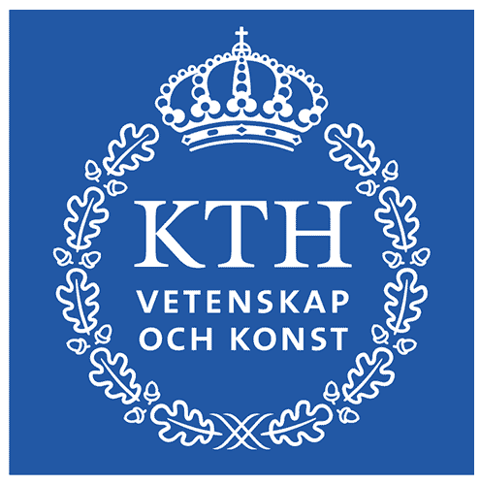
KTH Energy Dialogue 2022: Poster exhibition

Submit your energy poster to the poster competition and win a full communication training day!
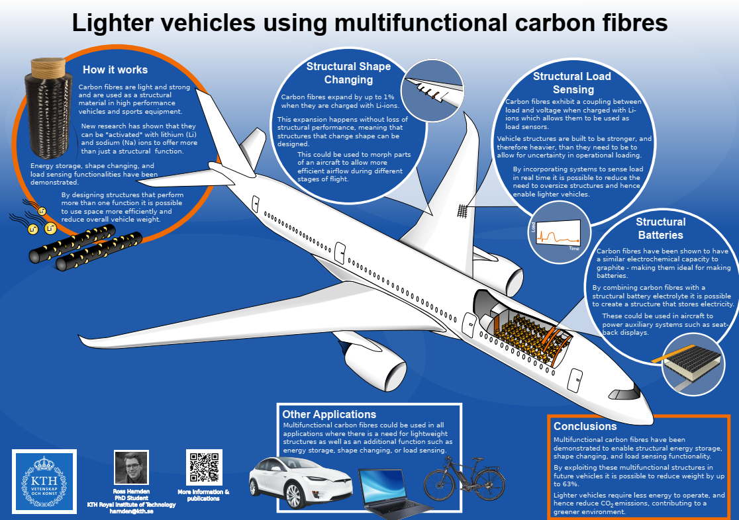
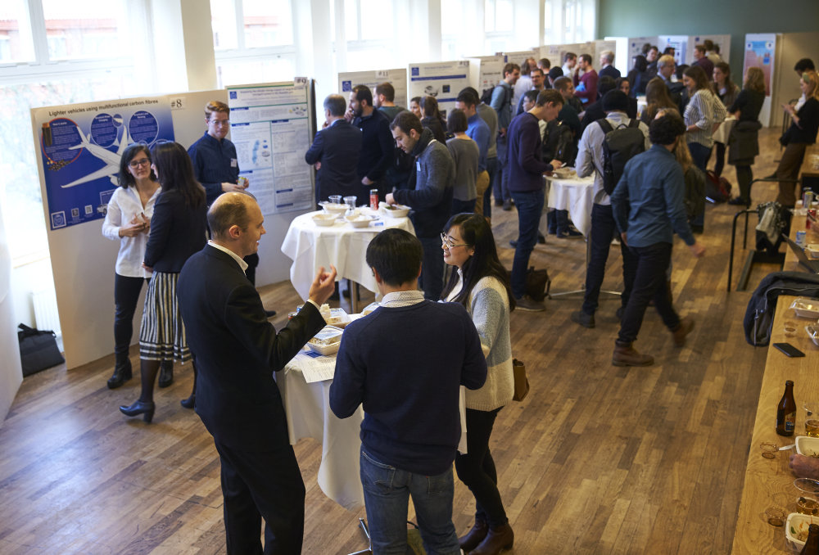
Pictures Above: winner 2019 Ross Harnden – the Poster exhibition in 2019

Big challenges are solved together! Impact is a key concept for research so please share your research with all KTH Energy Researchers and give participants of the KTH Energy Dialogue 2022 a taste of the best energy research at KTH. We welcome all KTH energy researchers to present a poster
A poster competition will be held during the KTH Energy Dialogue 2022 on November 17th 2022, organist by the KTH Energy Platform. All KTH researchers are welcome to submit a poster, and a jury will select the three best posters with respect to three criteria: (I) Innovative design, (II) Clarity and communication qualities, & (III) Accessibility for a broad audience without specific knowledge in the field.

The 3 winners will receive a full day communication training with feedback organized by professionals from Vetenskap & Allmänhet, value: SEK 5000. It includes selecting material, blog writing, video, ….

How to participate:
- You are a researcher at KTH and be registered for the KTH Energy dialogue 2022. Register here
- Your poster should present relevance for a least two Sustainable Development Goals
- You should submit the poster as .pdf file latest November 7th, 2022 by Email to energyplatform@kth.se with title [Best Poster Award 2022]. We will print the poster when accepted.
- You will present the poster during the dedicated session and should accompany with a 1-min pitch.

Check list:
Content. Concrete and clear impact, is it easy to understand for non-specialists? What are the 3 points that the public should remember?

Visual lay-out. Is the poster easy to read from a distance of 3 meters? Is it pleasing for the eye?

Interaction with the poster. How do you interact with the guests at KTH Energy Dialogue? Can you make then interested within 1-min?

To help you selected the content, Anders Sahlman (Vetenskap & Allmänhet) has published a serie of short tutorial. The jury selecting the best posters, includes Mona Hambreus, Swedish Radio; Cissi Askwall, Vetenskap & Allmänheten; and Francesco Fuso-Nerini, KTH Climate Action Centre.

