4. Selection guide when recruiting doctoral students
When the deadline has passed, an initial selection is made from all candidates based on their application documents and the employment profile, including: basic and, if relevant, specific entry requirements as well as personal characteristics and other meritorious knowledge and qualities experience.
The candidate’s application is matched up to the employment profile. Explain why you have selected or rejected any given candidate based on the employment profile.
A good selection based on the competence-based recruitment model helps ensure that the recruitment process meets KTH’s vision regarding equality, diversity and equal work conditions, as well as the requirements of the Discrimination Act (link to The Equality Ombudsman DO).

Overview

4.1 Entry requirements
Make sure that the candidate meets the basic eligibility for third-cycle education. According to Chapter 7 of the Higher Education Ordinance, the candidate must:

Meet the basic eligibility in accordance with either of the following:
- passed a degree at advanced level,
- Completed course requirements of at least 240 higher education credits, of which at least 60 higher education credits at advanced level, or
- in any other way acquired within or outside the country acquired essentially equivalent knowledge.

Meet the specific entry requirements:
- the specific eligibility requirements that KTH may have stated in the subject’s study plan and which also must be included in the advertisement.
- Rank eligible and ineligible candidates. Further down is a description of the three procedures that you can use in the recruitment system.

4.2a: Personal characteristics
Among candidates who meet the basic and specific entry requirements, the selection should be made with consideration to their ability candidates’ ability to benefit from studies at doctoral level. According to KTH’s admission regulations (in Swedish), the primary characteristics to be evaluated when admitting persons to doctoral studies are personal maturity, judgement and capacity for independent critical analysis.
To ensure that candidates are assessed equally, the KTH HR department has turned these into four personal characteristics based on the competence-based recruitment model:
- Autonomous (personal maturity, judgement) – Takes responsibility for own task. Structures own ways of tackling problems and pushes own processes through.
- Ability to co-operate (personal maturity, judgement) – Works well with other people. Relates to them in a sensitive way. Listens, communicates and solves conflicts constructively.
- Personal maturity (personal maturity, judgement) – Is secure, stable and possesses self-knowledge. Sees relations in their right perspectives, and separates the personal from the professional. Adapts own attitude to the situation.
- Problem solving analytical ability (capacity for independent critical analysis) – Works well with complex issues. Analyses and breaks down problems to its components and solves complicated problems.
In addition to KTH’s four pre-selected competences for doctoral studies admission above, additional personal characteristics can be added, and specified in the advertisement.
- The personal characteristics are mainly evaluated in the competence-based interview but can also be described in the application documents.
Remember: Before making a selection and holding interviews, the recruitment group needs to understand the definition of each respective personal characteristic, and what is means in the specific role/position. The recruitment group also needs to agree on which personal characteristics are most important.
4.2b: Meritorious knowledge and qualities
In addition to basic and specific eligibility requirements and personal qualities, there are other experience, qualities or skills that are desirable but which are not a requirement for eligibility. These are referred to as meritorious knowledge and experience.
The advertisement specifies what the meritorious knowledge and experience are for the position in question.
- Rank the candidates based on how well they match the list of meritorious knowledge and experience. Below is a description of the three procedures that you can use in the recruitment system.
Remember: Before selection begins, the recruitment group needs to agree on what meritorious knowledge and experience experience are most important.

Telephone calls and personal interviews
The interesting candidates are called up for an initial discussion and the chosen candidates are then invited to personal interviews, either in person or by Skype.

Ranking the candidates
The recruitment system offers three ways of ranking the candidates.
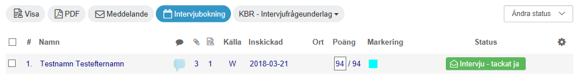

Status
Using status marking is the easiest way to rank and mark the candidates. Each candidate has their eligibility and ability to make use of the education marked with one of the following statuses:
Very interested
Interesting
Maybe interesting
Not interesting (not eligible)

The candidates are then marked according to if they have been contacted by phone or had a personal interview:

Contacted
Interview

Finally, the current status is selected:
Interview 2
Testing
Referrals taken
Offered employment
Employed

Highlighting
There are 15 colours which can be used to mark the candidates. Those who review the application documents need to agree on what each colour signifies.

Points
When using points, the characteristics and experience should be given points from the start. The scale is 1-100.

