Ranking the candidates in the recruitment system Varbi
The recruitment system offers three ways of ranking the candidates.
- Status
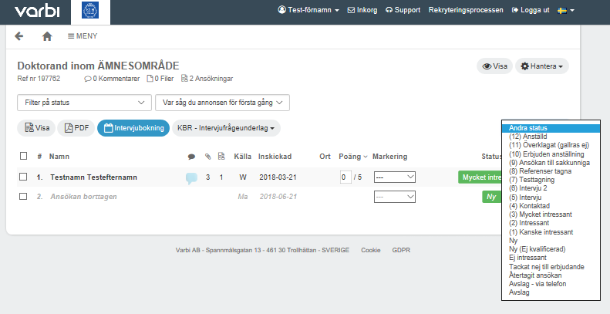
Mark the application and select the appropriate status.

- Points
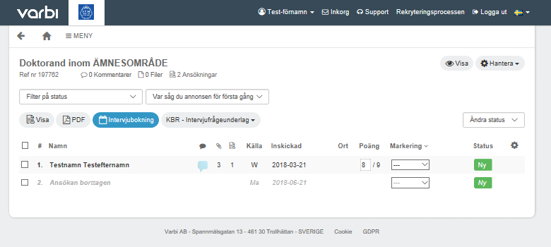
Type in a number and the application will be updated with points. When using points, the characteristics and experience should be given points from the start. The scale is 1-100.

- Highlighting
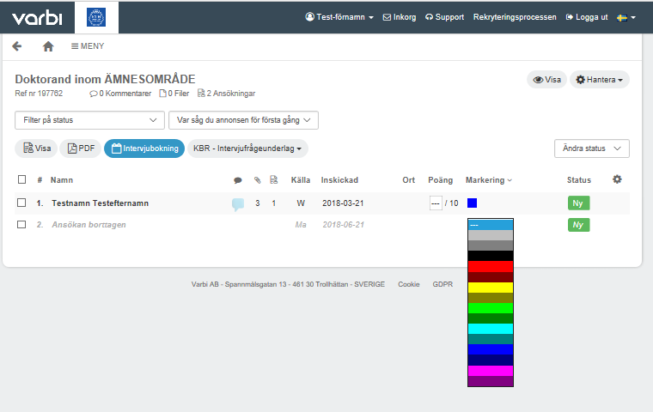
There are 15 colours which can be used to mark the candidates. Those who review the application documents need to agree on what each colour signifies.

