Environmental group meeting
Date: 2018-09-06
Location: Scilifelab Tomtebodavägen 23 A, house Alfa, floor 5, room Kinnekulle 13.30-15.30.
Agenda
- Presentation of present group memebers
Secretary for the meeting Thèrése Feierbach
CBH Intranet https://intra.kth.se/cbh/arbetsplatsen/miljoarbete/miljoarbete-pa-cbh-1.764349
Presentation of group members
Peter Savolinen – Campus SciLife, Genteknologi
Haichun Liu – Campus Albanova, Teoretisk Kemi och Biologi
Cecilia Mattsson – Campus SciLife, Affinitets-proteomik
Matthäus Bäbler – Campus Valhallavägen, KET
Kristina Holmberg - CBH, Miljöombud
Catharina Silverbrandt Lind – CBH, Miljöombud
Cia Persson – Campus Valhallavägen, IP
Thèrése Feierbach – Campus Valhallavägen, Verksamhetsstöd

- Purpose of those meetings
  - Have regular meetings regarding enviromental work.. The group will meet twice a semester
  - Communicate issues, suggestions, for improvment and environmental work to departments. Give and take information
  - principen Plan-Do-Check-Act-Plan…
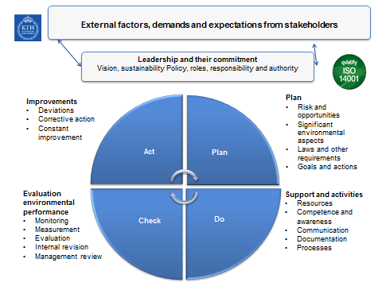
- Follow up from last meeting
- External audit
Deviation (Transport document hazardous waste can not be shown to be established) is closed.
  - documentation finished
  - follow – up (Daniel) that we now follow the regulation
Improvement proposals
- we have sent in responses to all
- Nonconformities and suggestions for improvement
  - Link to Nonconformities and suggestions for improvement on the intranet is done.
  - The issue of rooms to keep the bicycles in has been submitted to KTH centrally.

- Status actions environmental goals CBH
- Travels
- Information regarding meeting room equipped with possibilities to have meeting via link will be presented at the intranet - Kicki.
- Chemicals
- implementation of barcodes in KLARA - Daniel
- Riskassessment – group members and head of department
- CMR – group members, head of department and Mia H
Deadline for this is 2018-10-15

- Information from Sustainability office
Information from the meeting 2018-09-05
Reorganisation within Environmental group and how it will be handed in the future

- Nonconformities and suggestions for improvement
Blocked escape routes (Scilifelab), this issue has been reported to the Scilife administration several times without any results.
Should be reported as incident (by P. Savolainen) to KTH “report envirommental nonconformatives or suggestions for improvements” https://intra.kth.se/en/styrning/miljo-hallbar-utveckling/miljoledningssystem/rapportera-miljoavvikelse-eller-forbattringsforslag-1.408073
And to HR at CBH
https://intra.kth.se/polopoly_fs/1.656652!/Anm%C3%A4lan_av_tillbud_risk_och_arbetsskada_2018-07-04.pdf

- Internal audit
November 7 th 9.00-16.30

- Other questions

- Next meeting 2018-11-28, 13:30-15:30, Flemingsberg (Björn bokar lokal)

