ICM 2019 – Internal Application

Introduction

Erasmus+ International Credit Mobility is the action that funds mobility grants between EU/EFTA (programme countries) universities and partner universities from other regions of the world (partner countries). One single application per university is submitted every year, including a number of projects (one per partner country for which interest has been expressed either by KTH as a whole or by a School (through one of its staff members).

If you are interested in submitting a project with one or more partner universities, we invite you to read the information below and to fill out the annexed internal application form and the table summarizing the number and type of grants you are applying for. Please contact Mohammad Saleh or Mirko Varano for advice to the project proposal.

Please note that the programme covers only travel costs and accommodation/subsistence costs through lump sums (no salaries). Outbound mobility for staff are handled through the KTH travel system. Grants for inbound mobility are handled by the International Relations Office at KTH.

Different budgets are allocated to different regions of the world, so we invite you to consult the budget summary before applying.

Guidelines

- Only existing co-operations are eligible for funding (the action cannot be used to establish cooperation with brand new partners) and the previous cooperation activities with the partner are an important component of the application

- One form per partner country has to be filled out

- Period for which the mobilities are eligible: August 2020 – August 2023

- All academic levels are eligible and there are no restrictions in term of disciplines and fields of study

- There are two different categories for staff mobility:
  - teaching periods: this activity allows HEI teaching staff or staff from enterprises to teach at a partner HEI abroad. Staff mobility for teaching can be in any subject area/academic discipline.
  - training periods: this activity supports the professional development of HEI teaching and non-teaching staff as well as the development of involved institutions. It may take the form of training events abroad (excluding conferences) and job shadowing/observation periods/training at a partner HEI, or at another relevant organisation abroad.

- Mobility rules:
  - Bachelor and Master students: 3 – 12 months for studies (2 – 12 months for traineeships), only if reciprocity and balance are guaranteed (an exchange agreement should be in place at the moment of application). Note that Swedish migration requires a minimum workload of 30 ECTS.
  - PhD: 3 – 12 months (no salaries covered by the programme)
  - Staff for teaching (academics only): 5 days – 2 months
  - Staff for training (including administrative staff): 5 days – 2 months
- The following geographical targets set by the European Commission for the budget allocated to each country should be taken into consideration:
  - With Developing Asia and Latin America, 25% of the funds should be used to organize mobility with the least developed countries of the region. These countries are:
    - For Asia: Afghanistan, Bangladesh, Cambodia, Laos, Nepal, Bhutan and Myanmar;
    - For Latin America: Bolivia, El Salvador, Guatemala, Honduras and Nicaragua;
  - No more than 30% of the budget available for Asia should be spent on mobility with China and India;
  - And no more than 35 % available for Latin America on Brazil and Mexico.

- The application must include the point of view and strategy of the partner university (ask for contributions well in time)

- Underline in which way the cooperation will benefit both partners

- Only applications including a minimum of 6 mobilities will be accepted

- Student mobility must be confirmed by the mobility officer at the school

- The mobility scheme should be balanced (i.e. the number of incoming and outgoing beneficiaries should be similar although not identical)

The text should be clear and cover all the listed items (minimum two A4 pages of text in total). Please note that questions 1 and 2 are worth 60% of the total score while items 3 and 4 weight 40% of the total score. Hence extra effort should be made here. See page 5.
The form “Skolans medgivande”, duly signed, shall be attached to the application. The applicant shall be able to handle the administrative responsibility for an ICM mobility project.

- Deadline for submitting the filled out form and table to the International Relations Office via e-mail (mohsaleh@kth.se): 10 January 2020

- Only applications complying with the minimum requirements listed here above and meeting a minimum quality standard in the contents will be submitted, i.e. a) covering all the requested elements in an exhaustive manner for both KTH and the partner institution; b) the proposal is building on an existing cooperation; c) a balanced mobility scheme with a minimum of 6 participants and, if applicable, with approved student mobility; d) a completed and signed School Approval Form /Skolans medgivande)

- After the quality check, the International Relations Office will either approve the project or reject it and contact the project coordinators if the application needs to be improved or completed before submission

Funding rules

Travel costs for students
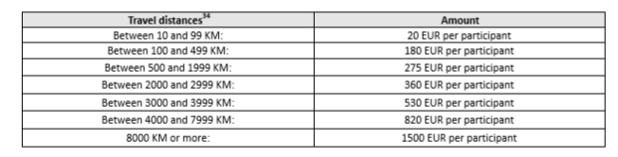

Individual support/allowance for students

The amount of the monthly allowance for the incoming beneficiaries depends on the country of origin while the allowance for KTH students is fixed (700 €).
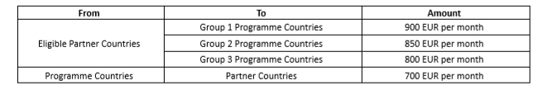

Grant support for the mobility of staff

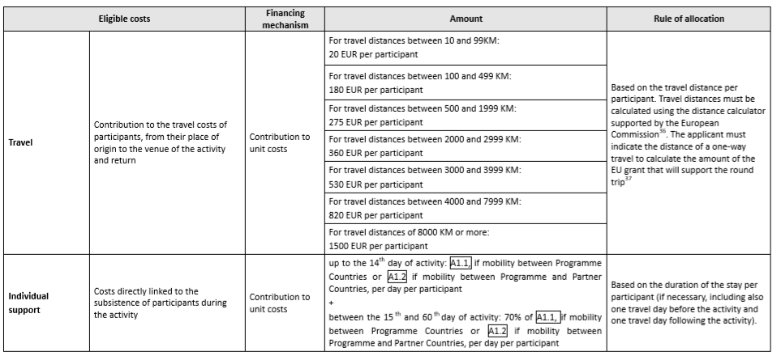

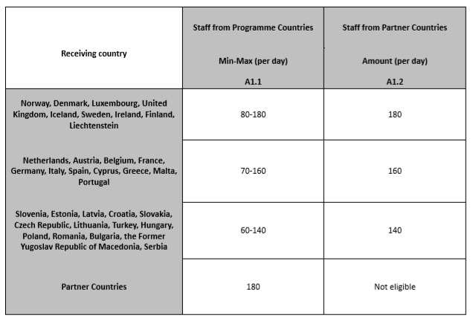

The organisational support grant is a 350 € contribution, for each approved individual grant, to any cost incurred by the institutions in relation to activities in support of student and staff mobility, both inbound and outbound. For example:
- organisational arrangements with partner institutions, including visits to potential partners, to agree on the terms of the inter-institutional agreements for the selection, preparation, reception and integration of mobile participants; and to keep these inter-institutional agreements updated;
- provide updated course catalogues for international students;
- provide information and assistance to students and staff;
- selection of students and staff;
- preparation of the learning agreements to ensure full recognition of the students’ educational components; preparation and recognition of mobility agreements for staff;
- linguistic and intercultural preparation provided to both incoming and outbound students and staff, complementary to the Erasmus+ Online Linguistic Support;
- facilitate the integration of incoming mobile participants in the HEI;
- ensure an efficient mentoring and supervision arrangements of mobile participants;
- specific arrangements to ensure the quality of student traineeships in enterprises;
- ensure recognition of the educational components and related credits, issuing transcript of records and diploma supplements;
- support the reintegration of mobile participants and build on their acquired new competences for the benefit of the HEI and peers

Internal Application form

To be submitted to KTH International Relations office; Mohammad Saleh, mohsaleh@kth.se Deadlline: 10 January 2020

Country of the partner university:……………………………………

Partner university:………………………………………………………

Name of the KTH coordinator and School/Department:

……...…………………………………………………………………….

e-mail address:………………………………………………………….

Description of the collaboration:

- Relevance of the strategy (30 p.) ( Maximum 5000 characters)

- explain why the planned mobility project is relevant to the Internationalization strategy of the Programme and Partner Country HEIs involved

- justify the proposed type(s) of mobility (students and/or staff) and in which way they will contribute to boost the cooperation between the two partners or carry out planned activities that would otherwise not take place

- Quality of the cooperation arrangements (30 p.) ( Maximum 7000 characters)

- previous experience of similar projects with HEI institutions in this Partner Country, if any

- explain how, for the planned mobility project, responsibilities, roles and tasks will be defined in the Inter-institutional Agreement. Who will be responsible for what at each institution

- Quality of project design and implementation (20 p.) ( Maximum 7000 characters)

- present the different phases of the mobility project and summarize what partner organizations plan in terms of selection of participants, the support provided to them and the recognition of the mobility periods (in particular in the Partner Country)

- Impact and dissemination (20 p.) ( Maximum 7000 characters)

- explain the desired impact of the mobility project on the participants, beneficiaries, and partner organizations, at local, regional and national levels. How will these activities benefit other individuals not directly involved in the mobilities

describe the measures which will be taken to disseminate the results of the mobility project at faculty and institutional levels, and beyond where applicable, in both the Programme and Partner Countries

Summary of the requested grants

Level | Direction | Number of grants | Total number of months/days (specify)
Bachelor | Incoming
 | Outgoing
Master | Incoming
 | Outgoing
PhD | Incoming
 | Outgoing
Staff for teaching | Incoming
 | Outgoing
Staff for training | Incoming
 | Outgoing

Checklist for the Project Proposal

The guide “Dos and Don’ts for Erasmus+ ICM mobility has been consulted”.

The proposal is building on an existing cooperation.

The description of the collaboration covers the perspective and strategy for both parties. The answers to the questions provides detailed information, ½ - 1 A4 page per question.

The proposal has a balance mobility scheme with a minimum of 6 participants.

If applicable: the proposed student mobility builds on an existing exchange agreement.

The Project proposal has an assigned project leader and project administrator (this can be the same person).

The duly signed School approval form is attached.

