Environmental group meeting
Date: 2018-11-28
Location: KTH Flemingsberg, Konferensrum 7320
Chairman of the meeting: Kicki Holmberg
Sectretary for the meeting: Matthäus Bäbler

Attendants:
Matthäus Bäbler – Campus Valhallavägen, Institutioner för Kemiteknik
Thèrése Feierbach – Campus Valhallavägen, Verksamhetsstöd
Kicki Holmberg – CBH, Miljöombud
Sara Kanje – Campus Albanova, Institutioner för Proteinvetenskap
Haichun Liu – Campus Albanova, Institutioner för Teoretisk Kemi och Biologi
Cecilia Mattsson – Campus SciLife, Institutioner för Proteinvetenskap
Anna Martinez Casals – Campus SciLife, Institutioner för Proteinvetenskap
Lauren McKee – Campus Albanova, Institutioner för Kemi (Division of Glycoscience)
Björn Nordbäck – Campus Flemingsberg, Infrastruktur & Internservice
Christina Persson – Campus Valhallavägen, Institutioner för Ingeniörpedagogik
Daniel Tavast – CBH, Infrastrukturansvarig

- Opening and purpose of the meeting
- Kicki opens the meeting and presents the agenda for the meeting. She emphasizes the importance oft the intranet for finding information regarding safety. Also she welcomes the new temporary member, Anna Martinez Casals from SciLife, who substitutes Cecilia for the next meetings.
- Next, she explains the purpose of the meeting and repeats the role of the Environmental Group at CBH by referring to the “Plan-Do-Check-Act” strategy brought up in previous meetings. She in particular emphasizes the groups role as link between the different departments at CBH.

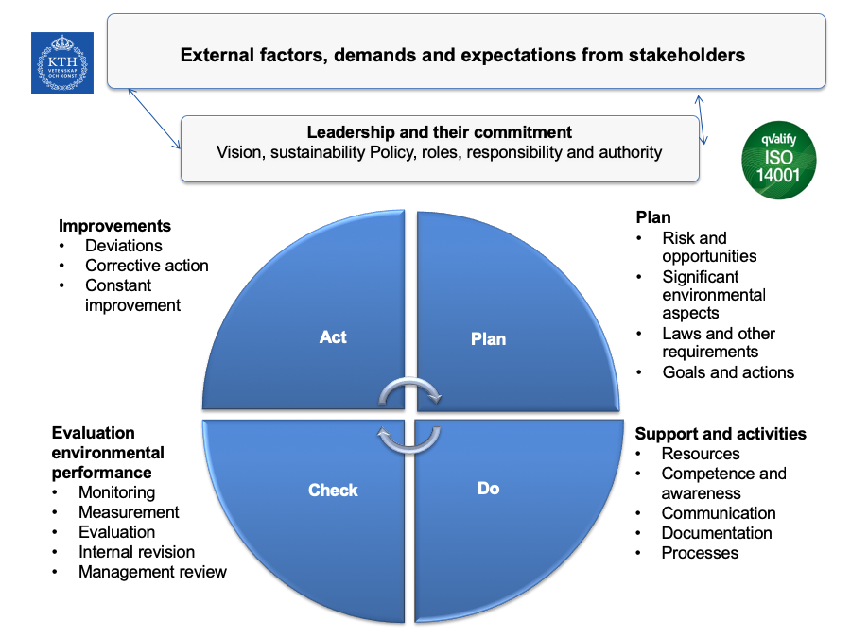

Christina remarks that she finds it a pity that this slide is not on the intranet.

- Follow up from last meeting
- Blocked escape routes in the SciLife lab. The issue of blocked escape routes was first brought up in the meeting on 2018-09-06. Cecilia reports that the issue still exists and that another incident occurred since the last meeting. Daniel and Kicki suggest that the issue is to be put forward to the Infrastructure personnel at the SciLife building, namelz Jóna Guðjónsdóttir (jona.gudjonsdottir@kth.se)

- Status actions environmental goals CBH
There are several environmental goals CBH aims at achieving:
- Reduction of traveling. Kicki remarks that reducing traveling is one of the key issues of the headmaster of KTH. A list of meeting rooms with facilities for video conferencing is available of the intranet. The proposal to voluntarily pay a traveling tax has been dismissed by KTH.
- KLARA: Daniel reports that the implementation of barcodes on KLARA is done. Also, he reports that the number of Risk Assessments added to KLARA has been increased.
There is some issues with access to the data on KLARA: Staff at SciLife only have access to data from their Department. Daniel points out that right now he cannot change the access rights for KLARA users at this very moment. However, he informs that there will be a meeting next week and he will ask for advanced access rights such that he can modify the user rights.
- CMRs. There are so far only 3 CMR that have been sent to Maria (Mia) Hjertén (mahjer@kth.se). It turns out that some groups have them ready but did not know where to send them.

- Information from the internal audit
- An internal audit took place in early October where in internal committee visited the Protein Lab at Albanova Campus. It was positive to see the coupling of undergrad education and research that is cultivated at the Protein lab. Regarding the safety, the committee has not yet sent their final report, but no major deviations have been found.
- The committee also evaluated the management team as well as research and education. Kicki points out that KTH works now to develop accretion criteria for incorporating environmental and sustainability questions more systematically into the curriculum.

- Information from the Ledningsuppföljning
Kicki reports on some developments at KTH. A decision form KTH aims at removing the “miljöombuds” (MO) and replace them by a central group which is allocated directly to the university board. A discussion evolves among the attendees that some questions requires the input form various levels and also that some issues need more support from the research PI and the head of departments which would be difficult in structure where everything is handled by a central group. This is also the opinion of CBH, and hence, a pragmatic solution from CBH has been put in place:
- The miljöombud will be renamed to Envrionmental and Lab Safety Coordinator.
- The CBH Environmental Group is renamed to Environment and Lab Safety Group.
In practice there will be no difference to the working of the group.

- Non-conformities and suggestions for improvement
- Mercury thermometers: The internal audit found that some course labs still use mercury thermometers. These should be replaced, or, if a team decides to keep them, a risk assessment should be done and their use should be motivated.
- Environmental room at TK56: the signs indicating what kind of waste goes in each bin were checked and were deemed up-to-date. However, there are more modern signs that would allow for more efficient dissimation of information. Existing signs will be replaced any time soon.
In this context, Daniel explains that all non-corrugated cardboard should be put to “brännbar” waste. Only corrugated cart-board is recycled.
- Vacuum pumps. Another point comes up from Albanova regarding vacuum pumps, where we should not use anymore water pumps and instead use electric vacuum pumps. Sara Kanje (kanje@kth.se) reports that they just bought a new electric vacuum pump and she is happy to share information about its running.
- Safety procedures in labs. Lauren reports from their experience at Glucosciences in doing CMRs and risk assessment. She in particular points out that Glucoscience has well develop procedures to instruct new group members and student about safety in the lab. However, other teams they share lab space apply other safety standards which appears inadequate. Daniel responds that lab safety is among the priorities for the coming meetings and will be brought up at meetings with the heads of divisions.
A discussion evolves how responsibilities are distributed among the staff at KTH, and also how information from the management team should be disseminated to the level of employees.
- Christina reports that students complained about insects in the eating corners. Daniel replies that the eating rooms (with microwave ovens) are not part of CBH.

- Another two aspects.
Kicki reports on another two aspects:
- There was considerable vandalism at Flemingsberg that somebody destroys stuff. The issue is under investigation.
- At TK 42 there was a sever incident with a student who threatened the staff at the student-expedition. As an intermediate counter measure a guard is now full time at TK 42. Christina says that there should be better information to all staff about the situation because it felt kind of odd to find a security person in front of the student-expedition. Kicki explains that too much or too detailed information can also create unnecessary panic.

- Information on the website
Kicki guides the attendees through KTH’s Intranet and explains where the information of CBH (https://intra.kth.se/en/cbh) and the work of the environmental group can be found (https://intra.kth.se/en/cbh/arbetsplatsen/miljoarbete).

- Closing
Dates for three meetings in the first semester of 2019 are scheduled. Meetings are scheduled for:
- We, Feb. 6, 13.30-15.30 at Campus Albanova (Sara Kanje is asked to order coffee)
- We, April 4, 13.30-15.30 at Campus Teknikringen
- We, June 5, 13.30-15.30 at SciLife Lab,

